**SCORE ANALYSIS**

First of all we looked over score system and criteria of competition.. After a particular examination, we designed a Windows application it can be calculate every mission’s score system and total percantage. Also, this program shows percantage effects of all mission. And in this application all percentage of missions is graphed. The main template of the program is as follows:

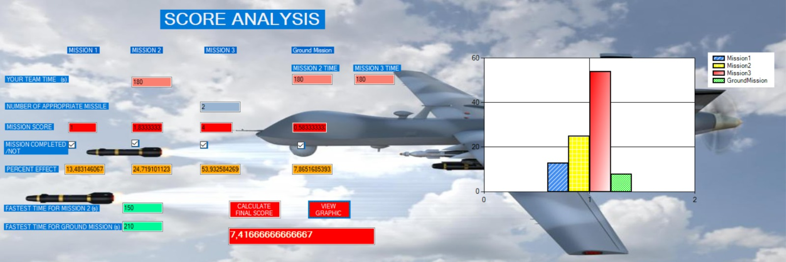

For undurstanding of every missions effect, we decrcase missions time and number of missile then increase again. In the graph on the left, the number of missiles fired was 2, while the percentange of missiles was 53,93%.In the right of the graph while the percentange of missiles was 3, while the number of missiles increased to 59,40 . This shows that 1 missile has an effect of close to 6%. On the fallowing figure, we observed the effects of missing.

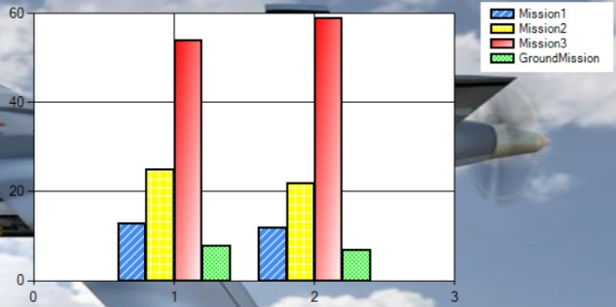

(Percentage of Mission 3 )

Other parameter is total time of mission 2 and ground mission. Here we try to make an inference by playing with the time parameter . These 2 tasks showed the same results as the score criterion. Mission 2 30 seconds after the fastest time to make the mission 2 the total score 24,71. After 60 seconds, this rate fell to 23.49 percent. So this value is 1,22 percent. The following chart shows a slight change in Mission 2.( The same results were observed in the ground mission)

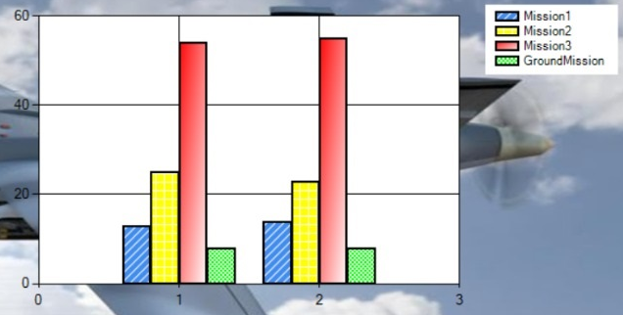

(Percentage of Mission 2 )

Considering these two observations, we decided that the speed factor is a parameter that can be negligible. Because being 1 minute behind the fastest time was about 1.5% depreciation. Throwing one more missile make the mission percentage increase up to %6. It is deduced that completing of the mission 3 with the maximum missile is of critical importance in terms of winning the race. Considering these observations, our team paid attention to these criteria when optimizing the UAV. Our team decided to build a vehicle that more stay in air and capable of launching more missiles rather than making faster vehicle. Considering these score parameters, battery selection and aerodynamic design of the device were performed.